Test 22.11.17

# Geändertes Create Script

drop table person cascade constraints;

drop table country cascade constraints;

drop table calls cascade constraints;

drop sequence seq_calls;

create sequence seq_calls;

create table person(pnr integer primary key, pname varchar2(20));

create table country (country_id integer primary key, country_name varchar2(20));

create table calls(call_nr integer, pnr integer references person(pnr),

country_id integer references country (country_id),

duration integer,

date);

insert into person values (1,'Einstein');

insert into person values (2,'Zweistein');

insert into person values (3,'Dreistein');

insert into person values (4,'Vierstein');

insert into person values (5,'Benedikt?');

insert into country values (0043,'Austria');

insert into country values (0044,'Great Britain');

insert into country values (0046,'Germany');

insert into country values (0046,'Kaernten');

insert into calls values(seq_calls.NEXTVAL,1,0043,100,'01.01.2016');

insert into calls values(seq_calls.NEXTVAL,1,0043,100,'01.02.2016');

insert into calls values(seq_calls.NEXTVAL,1,0043,100,'01.02.2016');

insert into calls values(seq_calls.NEXTVAL,1,0044,10,'01.02.2016');

insert into calls values(seq_calls.NEXTVAL,1,0044,10,'01.03.2016');

insert into calls values(seq_calls.NEXTVAL,1,0046,10,'01.03.2016');

insert into calls values(seq_calls.NEXTVAL,1,0046,100,'01.03.2016');

insert into calls values(seq_calls.NEXTVAL,1,0044,100,'01.02.2016');

insert into calls values(seq_calls.NEXTVAL,1,0044,100,'01.02.2016');

insert into calls values(seq_calls.NEXTVAL,1,0044,100,'01.02.2016');

insert into calls values(seq_calls.NEXTVAL,1,0044,10,'01.02.2016');

insert into calls values(seq_calls.NEXTVAL,1,0044,10,'01.03.2016');

insert into calls values(seq_calls.NEXTVAL,1,0046,10,'01.03.2016');

insert into calls values(seq_calls.NEXTVAL,1,0046,100,'01.03.2016');

insert into calls values(seq_calls.NEXTVAL,1,0043,10,'01.02.2016');

insert into calls values(seq_calls.NEXTVAL,1,0043,10,'01.02.2016');

insert into calls values(seq_calls.NEXTVAL,1,0043,10,'01.02.2016');

insert into calls values(seq_calls.NEXTVAL,1,0043,10,'01.03.2016');

insert into calls values(seq_calls.NEXTVAL,1,0043,10,'01.03.2016');

insert into calls values(seq_calls.NEXTVAL,1,0043,10,'01.03.2016');

insert into calls values(seq_calls.NEXTVAL,1,0046,10,'01.03.2016');

insert into calls values(seq_calls.NEXTVAL,1,0044,10,'01.03.2016');

insert into calls values(seq_calls.NEXTVAL,1,0044,10,'01.03.2016');

insert into calls values(seq_calls.NEXTVAL,1,0044,10,'01.03.2016');

insert into calls values(seq_calls.NEXTVAL,1,0044,10,'01.03.2016');

insert into calls values(seq_calls.NEXTVAL,1,0044,100,'01.04.2016');

insert into calls values(seq_calls.NEXTVAL,1,0043,100,'01.04.2016');

insert into calls values(seq_calls.NEXTVAL,1,0046,10,'01.04.2016');

insert into calls values(seq_calls.NEXTVAL,1,0044,10,'01.04.2016');

insert into calls values(seq_calls.NEXTVAL,1,0044,10,'01.04.2016');

insert into calls values(seq_calls.NEXTVAL,1,0044,10,'01.04.2016');

insert into calls values(seq_calls.NEXTVAL,1,0044,10,'01.04.2016');

insert into calls values(seq_calls.NEXTVAL,1,0044,10,'01.04.2016');

insert into calls values(seq_calls.NEXTVAL,1,0043,10,'01.04.2016');

insert into calls values(seq_calls.NEXTVAL,1,0046,10,'01.04.2016');

insert into calls values(seq_calls.NEXTVAL,1,0044,10,'01.02.2017');

insert into calls values(seq_calls.NEXTVAL,1,0044,10,'01.02.2017');

insert into calls values(seq_calls.NEXTVAL,1,0044,10,'01.02.2017');

insert into calls values(seq_calls.NEXTVAL,1,0044,10,'01.02.2017');

insert into calls values(seq_calls.NEXTVAL,1,0044,10,'01.03.2017');

insert into calls values(seq_calls.NEXTVAL,1,0043,100,'01.03.2017');

insert into calls values(seq_calls.NEXTVAL,1,0046,10,'01.04.2017');

insert into calls values(seq_calls.NEXTVAL,2,0044,10,'01.02.2016');

insert into calls values(seq_calls.NEXTVAL,2,0044,10,'01.02.2016');

insert into calls values(seq_calls.NEXTVAL,2,0044,10,'01.02.2016');

insert into calls values(seq_calls.NEXTVAL,2,0044,10,'01.02.2016');

insert into calls values(seq_calls.NEXTVAL,2,0044,10,'01.03.2016');

insert into calls values(seq_calls.NEXTVAL,2,0044,10,'01.04.2016');

insert into calls values(seq_calls.NEXTVAL,2,0044,10,'01.04.2016');

insert into calls values(seq_calls.NEXTVAL,2,0043,10,'01.05.2017');

insert into calls values(seq_calls.NEXTVAL,2,0043,10,'01.05.2017');

insert into calls values(seq_calls.NEXTVAL,2,0043,10,'01.06.2017');

insert into calls values(seq_calls.NEXTVAL,2,0043,10,'01.06.2017');

insert into calls values(seq_calls.NEXTVAL,2,0043,10,'01.06.2017');

insert into calls values(seq_calls.NEXTVAL,2,0043,10,'01.08.2017');

insert into calls values(seq_calls.NEXTVAL,2,0043,10,'01.08.2017');

insert into calls values(seq_calls.NEXTVAL,2,0044,10,'01.04.2016');

insert into calls values(seq_calls.NEXTVAL,2,0044,10,'01.04.2016');

insert into calls values(seq_calls.NEXTVAL,2,0044,10,'01.04.2016');

insert into calls values(seq_calls.NEXTVAL,2,0044,10,'01.04.2016');

insert into calls values(seq_calls.NEXTVAL,4,0044,10,'01.04.2016');

insert into calls values(seq_calls.NEXTVAL,4,0043,10,'01.04.2016');

insert into calls values(seq_calls.NEXTVAL,4,0046,10,'01.04.2016');

insert into calls values(seq_calls.NEXTVAL,2,0044,10,'01.02.2017');

insert into calls values(seq_calls.NEXTVAL,2,0044,10,'01.02.2017');

insert into calls values(seq_calls.NEXTVAL,2,0044,10,'01.02.2017');

insert into calls values(seq_calls.NEXTVAL,4,0044,10,'01.02.2017');

insert into calls values(seq_calls.NEXTVAL,4,0044,10,'01.03.2017');

insert into calls values(seq_calls.NEXTVAL,4,0043,10,'01.03.2017');

insert into calls values(seq_calls.NEXTVAL,4,0046,10,'01.04.2017');

insert into calls values(seq_calls.NEXTVAL,3,0044,100,'01.02.2017');

insert into calls values(seq_calls.NEXTVAL,3,0044,100,'01.02.2017');

insert into calls values(seq_calls.NEXTVAL,3,0044,100,'01.02.2017');

insert into calls values(seq_calls.NEXTVAL,3,0044,10,'01.02.2017');

insert into calls values(seq_calls.NEXTVAL,3,0044,10,'01.03.2017');

insert into calls values(seq_calls.NEXTVAL,3,0043,10,'01.03.2017');

insert into calls values(seq_calls.NEXTVAL,3,0046,10,'01.04.2017');

insert into calls values(seq_calls.NEXTVAL,2,0043,20,'01.06.2017');

insert into calls values(seq_calls.NEXTVAL,2,0043,70,'01.06.2017');

# Beispiel 1:

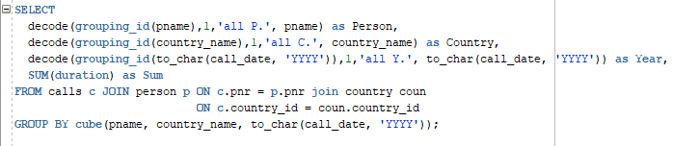

SELECT

decode(grouping_id(pname),1,'all P.', pname) as Person,

decode(grouping_id(country_name),1,'all C.', country_name) as Country,

decode(grouping_id(to_char(call_date, 'YYYY')),1,'all Y.', to_char(call_date, 'YYYY')) as Year,

SUM(duration) as Sum

FROM calls c JOIN person p ON c.pnr = p.pnr join country coun

ON c.country_id = coun.country_id

GROUP BY cube(pname, country_name, to_char(call_date, 'YYYY'));

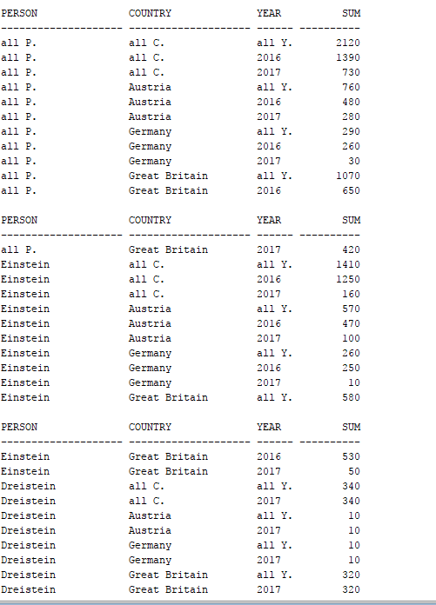

# Beispiel 2

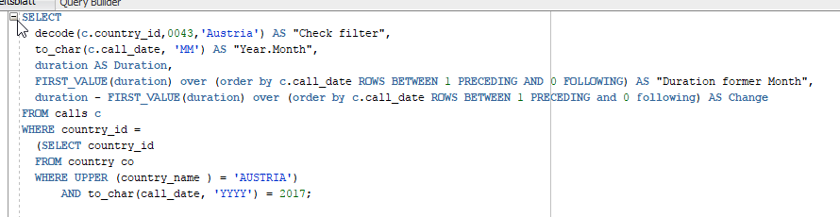

SELECT

decode(c.country_id,0043,'Austria') AS "Check filter",

to_char(c.call_date, 'MM') AS "Year.Month",

duration AS Duration,

FIRST_VALUE(duration) over (order by c.call_date ROWS BETWEEN 1 PRECEDING AND 0 FOLLOWING) AS "Duration former Month",

duration - FIRST_VALUE(duration) over (order by c.call_date ROWS BETWEEN 1 PRECEDING and 0 following) AS Change

FROM calls c

WHERE country_id =

(SELECT country_id

FROM country co

WHERE UPPER (country_name ) = 'AUSTRIA')

AND to_char(call_date, 'YYYY') = 2017;

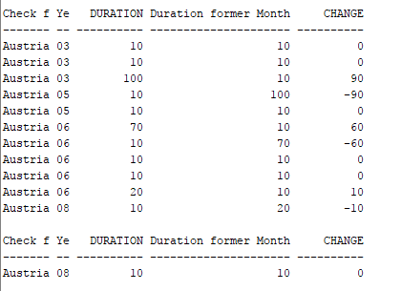

# Beispiel 3

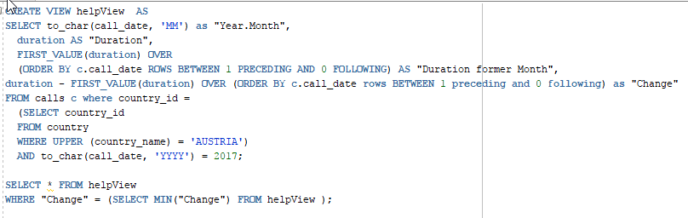

CREATE VIEW helpView AS

SELECT to_char(call_date, 'MM') as "Year.Month",

duration AS "Duration",

FIRST_VALUE(duration) OVER

(ORDER BY c.call_date ROWS BETWEEN 1 PRECEDING AND 0 FOLLOWING) AS "Duration former Month",

duration - FIRST_VALUE(duration) OVER (ORDER BY c.call_date rows BETWEEN 1 preceding and 0 following) as "Change"

FROM calls c where country_id =

(SELECT country_id

FROM country

WHERE UPPER (country_name) = 'AUSTRIA')

AND to_char(call_date, 'YYYY') = 2017;

SELECT * FROM helpView

WHERE "Change" = (SELECT MIN("Change") FROM v);

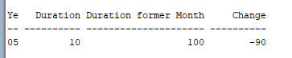

# Beispiel 4

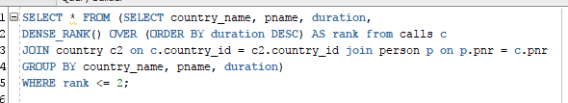

SELECT * FROM (SELECT country_name, pname, duration,

DENSE_RANK() OVER (ORDER BY duration DESC) AS rank from calls c

JOIN country c2 on c.country_id = c2.country_id join person p on p.pnr = c.pnr

GROUP BY country_name, pname, duration)

WHERE rank <= 2;

